Advanced Games Programming
Tutorial 07 - Orienting the Camera using the View Matrix

Introduction

In the previous tutorials you have been manipulating objects by various transformation matrices to rotate, scale and translate them into World space. As mentioned in in previous tutorials there is another transformation that represents the viewpoint and direction that you want to view the objects in the scene, the View Space Transform, and in this tutorial you will investigate how to create a virtual camera that can be manipulated to show different viewpoints using a View Matrix.

View Space Transform

World space transformations are used to move objects in a 3D world, but as most games require a dynamic viewpoint of the world you need some way to move the viewpoint around. This can be imagined as orienting and moving a virtual camera through the 3D world, and is represented by a View Space transformation. In essence you create a matrix that represents the position of your virtual camera, and the direction it is pointing, e.g.:

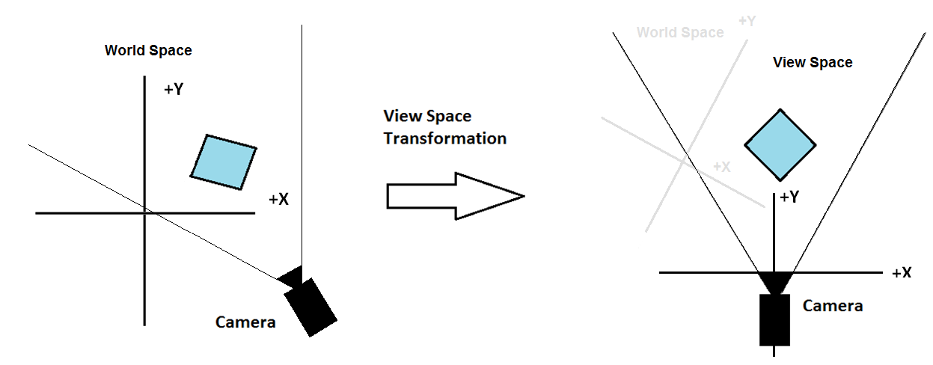

The Camera View

In the previous tutorial examples the View transformation matrix of the scene was set to the identity matrix. Essentially this meant that the position of the camera defaulted to the origin of world space, looking down the positive Z axis. Normally you would want to position the player in a particular location in the world, and give them a specific direction to look towards. In a very simple system the player could control the viewpoint in two ways:
- The player can rotate their viewing direction;
- The player can move their position forwards or backwards along their current viewing direction.
The player's current view is known as the camera because, like a real camera, it's facing in a particular direction, and is at a certain position in the world.
You could represent these operations and store the resulting position and view direction conveniently in a Camera class.

Positioning and Orientating the Camera

In order to position and orient the camera you need to create a View matrix representing the transformations required, so that this can be concatenated with the World and Projection matrices to form the final WorldViewProjection matrix. The maths required to create this matrix is quite complex, so fortunately Direct3D provides you with a handy function that generates one for you, XMMatrixLookAtLH(). This function takes three vectors, the first one representing the camera position, the second one the direction the camera is looking, and the third which is used to represent which way is 'up' for the camera. For now you can assume the 'up' vector is (0.0, 1.0, 0.0) i.e. pointing towards positive y as the simple you will create is only moving and rotating on the xz plane. The following code would move the viewpoint to (0.0, 0.0, -5.0) in the world, and set the view direction down the +z axis:

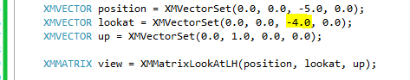

You may wonder why the XMVECTORs used have 4 components when you only need 3 to represent a 3D vector, and why they are set using a function rather than by setting the elements directly. This has been done in order to allow DirectX to optimise vector operations across several platforms.

Determining the Camera Orientation

So far you have simply aimed the camera along the positive z-axis. However, in a game, it's extremely unlikely that the camera will be pointing only in this direction. Typically, the player is able to rotate the camera so that it's pointing in any arbitrary direction. If the player rotates the camera, you need to work out what point it will be aiming at, based on the angle of rotation.

The Camera Angle

The XMMatrixLookAtLH()function allows you to orient the camera by passing in a camera position and another position which you aim the camera at called the look at point. It is perhaps more convenient to consider the camera to have a position and an angle that it has been rotated by. In your code you'd typically set the camera position and camera angle, then use simple trigonometry to convert the angle of view to the look at point. By convention, and to make the calculations simpler, the look at point is set to be at a distance of 1 unit from the camera whatever direction the camera is pointing.

Working out the Look At Point

For simplicity, let's first only consider left and right rotations, i.e. rotations about the y axis. The most convenient way of doing this for any given rotation is to calculate dx, the distance in the x direction from the camera position to the look at point, and dz, the distance in the z direction from the camera position to the look at point. Then, you can add dx and dz to the camera position to get the look at point.

Let's assume that a camera angle of 0 is pointing along the positive z axis, and that the angle increases clockwise as it is rotated about the y axis. Then, if you also assume a distance of 1 from the camera position to the point you're aiming for, it follows from the standard sin=opposite/hypotenuse, cos=adjacent/hypotenuse trigonometry rules that:

sin(Camera_Angle) = dx / 1

here there is a divide by one because the hypotenuse is the camera position to look at point, which has a distance of 1, therefore:

dx = sin(Camera_Angle)

similarly:

cos(Camera_Angle) = dz / 1

therefore:

dz = cos(Camera_Angle)

where Camera_Angle is the camera angle. This is shown on the diagram below:
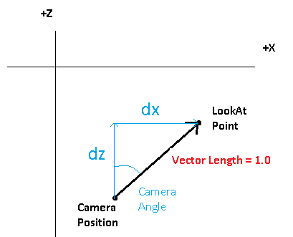

So, still assuming that the y axis is vertical, x, y, and z are the current coordinates of the camera, and camera_angle is the current camera angle, you can call XMMatrixLookAtLH()as follows:

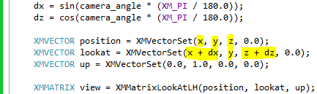

Note that as the assumption is just for movement along the xz plane the y coordinate of the point you're looking at will always be the same as the y coordinate of the current camera position. Note also how you have to convert the angle from degrees to radians for the cos() and sin() functions, which is why you multiply the camera angle by XM_PI / 180 (remember pi radians = 180 degrees)

Moving the Camera in the Direction of Rotation

It's now easy to control the camera with some basic controls. You could have four key presses, two to rotate the camera left and right (which would just increase and decrease the camera angle respectively by an appropriate amount), and two to move forwards and backwards along the current viewing direction. These last two are now easy to code. If step is the distance moved in one step, then to move forward just increase the camera x and z positions by step multiplied by the dx and dz values worked out above. This is because when you move forward, you are moving towards the point the camera is aiming at. Likewise, to move backward you subtract step multiplied by dx or dz from the current camera position's x or z coordinate. So the code to move the camera position would be:

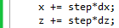

Tutorial 07 Exercise 01 - Creating a Camera class

You can now use what you learned to develop a simple camera control application, in which you set up a simple 3D world, and allow the user to rotate the camera and move forwards and backwards along the current viewing direction.
- Create a new project based on your Tutorial 06 Exercise 01 project (or one of the extra/advanced exercises), renaming it in the correct way.
- Add new camera.cpp and camera.h files to your project. You will need to include the d3d11.h, xnamath.h and math.h headers, don't forget to precede the xnamath header with the_XM_NO_INTRINSICS_ and XM_NO_ALIGNMENT defines.
- Create a Camera class, with private floating point attributes of m_x, m_y, m_z, m_dx, m_dz, and m_camera_rotation, and three XMVECTORS called m_position, m_lookat and m_up.
- Create a constructor that has 4 parameters, the initial x, y and z camera position, and the initial camera camera_rotation. Set the appropriate attributes, and also calculate the correct initial m_dx and m_dz values, don't forget to convert to radians.
- Create a Rotate() method that has a single floating point parameter that is the number of degrees to rotate the camera by (or use radians if you wish). Change the m_camera_rotation value by this amount. If the number is positive the camera should rotate to the right, and if negative to the left. Additionally update the m_dx and m_dz values as these will now be different for a new camera direction.
- Create a Forward() method that has a single floating point parameter that represents a distance the camera should move along the in the direction the camera is pointing. To do this update m_x and m_z using m_dx and m_dz multiplied by distance. If the distance is positive the camera should move forward, if it’s negative it should move backwards.
- You could also add an Up() method, this should be easy to implement.
- Create a method called GetViewMatrix() that takes no parameters but returns an XMMATRIX. This method should set the m_position, m_lookat and m_up vectors using the appropriate values, then use XMMatrixLookAtLH()to create a view matrix that should be returned from the method.
- Add a Camera pointer to the globals section in main.cpp. Don't forget to include the camera header.
- Towards the end of the InitialiseGraphics() function create a new camera at (0.0, 0.0, -0.5) with 0 rotation. If the last tutorial exercise was showing objects on screen, this camera initialisation should ensure they still are for this exercise, just slightly further away. If after completing the tutorial you can't see anything on screen, check all the Camera class carefully and step through the code in the debugger to try to understand why.
- Add keypress or mouse control to call the Rotate() and Forward() methods.
- In RenderFrame() call GetViewMatrix()to set the View matrix before creating the WorldViewMatrix.
- Delete the camera in ShutdownD3D().
- Move the camera around to ensure correct operation. You may want to add a few more objects to the scene to help get your bearings.

Tutorial 07 Exercise 02 – Adding strafe

Most cameras have more controls than the simple ones in Exercise 1. Cameras can strafe, i.e. move sideways left or right while facing ahead. The diagram below illustrates the idea:

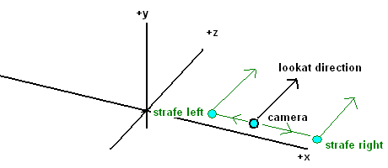

- Create a new project based on Tutorial 07 Exercise 01 called Tutorial 07 Exercise 02.
- Work out the calculations required to strafe left and right - remember, the camera should move left and right relative to the lookat direction, not the axes. Implement strafing in your camera class, considering any additional variables you may need, what calculations to perform, and any shortcuts you might be able to use to simplify the calculations. Some of the solution is given below to start you off:

void camera::Strafe(float distance)
{
/*Hint: Use the cross product calculation here first to calculate the direction*/
m_x += direction.x *distance;
m_z += direction.z * distance;
}

Tutorial 07 Exercise 03 – Moving up and down on the Y axis

- Work out the calculations required to move up and down on the Y axis. The solution to this one is really simple…
- This function could also be used for jumping and falling straight up and down, by applying a gravity factor. Implement jumping for later use.
- Slightly more complex would be jumping in an arc. Work out how to do this

Tutorial 07 Exercise 03 – Rotating the camera on the X axis

Cameras can also pitch - aiming upwards and downwards while pointing in the same ground direction. So if a camera was looking east along the ground, pitching upwards would result in it looking east towards the sky above the ground. The diagram below shows a side view of a camera, with the red arrow showing its original direction pointing directly down the positive x axis, and the blue arrows how it would end up after pitching up and down.
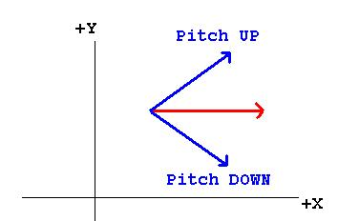
Use diagrams to work out the trigonometric equations necessary to implement pitch, and implement them in your camera class. You are not required to move the camera along the direction of view of the pitch, the forward and strafe functions can still move the camera around a horizontal xz plane.

You should populate your scene with many more cubes, and move around the scene to test the camera. Explore what happens with pitch angles above +-90 degrees - how can you solve this problem?

Hint:
- A simple way to solve the 90 degrees+ problem, is to simply restrict the max/min amount in degrees to less than 90 or greater than -90.
- You need to calculate m_dy now in the same way you calculated m_dx and m_dz.
- You will need to update the view matrix calculation to include m_dy.

